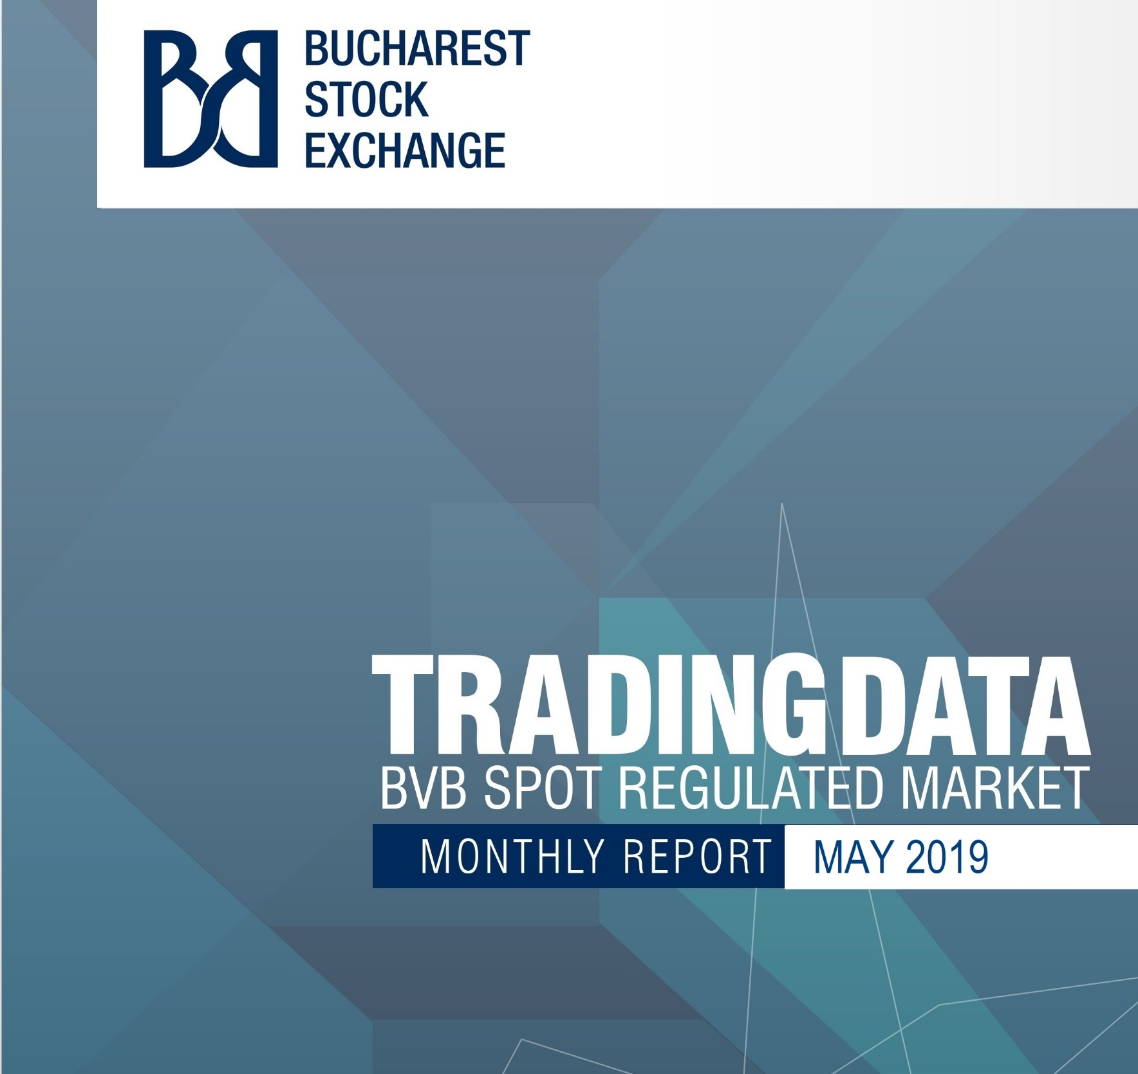

BVB Monthly Report

Trading value on BVB Regulated Spot Market
MAY 2019

- Summary of Main Indicators

- Trading value on the BVB’s Regulated Spot Market for May 2019 compared with April 2019

 | Total trading value  May 2019 |  | Total trading value  April 2019 |  | % Change
 | RON mil. | EUR mil. | RON mil. | EUR mil. | RON | EUR
Financial instruments already issued / registered | 1,057.54 | 222.23 | 574.43 | 120.75 | 84.10 | 84.04
- Equities | 1,023.98 | 215.18 | 554.78 | 116.62 | 84.57 | 84.51
- Bonds | 13.05 | 2.74 | 13.07 | 2.75 | -0.15 | -0.36
- Unit funds, ETF | 0.41 | 0.09 | 0.37 | 0.08 | 10.81 | 12.50
- Structured products | 20.11 | 4.23 | 6.21 | 1.30 | 223.83 | 225.38
New Issues and further issues
- Equities
- Bonds
Total Regulated Spot Market, out of which: | 1,057.54 | 222.23 | 574.43 | 120.75 | 84.10 | 84.04
- Total Equities | 1,023.98 | 215.18 | 554.78 | 116.62 | 84.57 | 84.51
- Total Bonds | 13.05 | 2.74 | 13.07 | 2.75 | -0.15 | -0.36

- Trading value on the BVB’s Regulated Spot Market for May 2019 compared with May 2018 (YoY)

 | Total trading value  May 2019 |  | Total trading value  May 2018 |  | YoY % Change
 | RON mil. | EUR mil. | RON mil. | EUR mil. | RON
Financial instruments already issued / registered | 1,057.54 | 222.23 | 743.97 | 160.33 | 42.15
- Equities | 1,023.98 | 215.18 | 711.28 | 153.28 | 43.96
- Bonds | 13.05 | 2.74 | 2.09 | 0.45 | 524.40
- Unit funds, ETF | 0.41 | 0.09 | 0.78 | 0.17 | -47.44
- Structured products | 20.11 | 4.23 | 29.83 | 6.42 | -32.58
New Issues and further issues
- Equities
- Bonds
Total Regulated Spot Market, out of which | 1,057.54 | 222.23 | 743.97 | 160.33 | 42.15
- Total Equities | 1,023.98 | 215.18 | 711.28 | 153.28 | 43.96
- Total Bonds | 13.05 | 2.74 | 2.09 | 0.45 | 524.40

- The value traded on the BVB’s Regulated Spot Market for January - May 2019 compared with January - May 2018 (YTD)

 | Total trading value  January - May 2019 |  | Total trading value  January - May 2018 |  | YTD % Change
 | RON mil. | EUR mil. | RON mil. | EUR mil. | RON
Financial instruments already issued / registered | 4,420.66 | 932.19 | 5,198.10 | 1,116.69 | -14.96
- Equities | 4,272.13 | 900.92 | 4,918.01 | 1,056.55 | -13.13
- Bonds | 82.76 | 17.41 | 129.17 | 27.71 | -35.93
- Unit funds, ETF | 1.99 | 0.42 | 4.45 | 0.96 | -55.28
- Structured products | 63.78 | 13.44 | 146.47 | 31.48 | -56.46
New Issues and further issues |  |  | 186.20 | 39.99
- Equities |  |  | 186.20 | 39.99
- Bonds
Total Regulated Spot Market, out of which: | 4,420.66 | 932.19 | 5,384.30 | 1,156.68 | -17.90
- Total Equities | 4,272.13 | 900.92 | 5,104.21 | 1,096.54 | -16.30
- Total Bonds | 82.76 | 17.41 | 129.17 | 27.71 | -35.93

- The average daily value on the BVB’s Regulated Spot Market for May 2019 compared with April 2019

 | Average daily value  May 2019 |  | Average daily value  April 2019 |  | % Change
 | RON mil. | EUR mil. | RON mil. | EUR mil. | RON | EUR
Financial instruments already issued / registered
- Equities | 46.54 | 9.78 | 27.74 | 5.83 | 67.77 | 67.75
- Bonds | 0.59 | 0.12 | 0.65 | 0.14 | -9.23 | -14.29
- Unit funds, ETF | 0.02 | 0.00 | 0.02 | 0.00 | 0.00 | 0.00
- Structured products | 0.91 | 0.19 | 0.31 | 0.07 | 193.55 | 171.43
New Issues and further issues
- Equities
- Bonds

- The average daily value on the BVB’s Regulated Spot Market for May 2019 compared with May 2018 (YoY)
age
 | Average daily value  May 2019 |  | Average daily value  May 2018 |  | YoY % Change
 | RON mil. | EUR mil. | RON mil. | EUR mil. | RON
Financial instruments already issued / registered
- Equities | 46.54 | 9.78 | 33.87 | 7.30 | 37.41
- Bonds | 0.59 | 0.12 | 0.10 | 0.02 | 490.00
- Unit funds, ETF | 0.02 | 0.00 | 0.04 | 0.01 | -50.00
- Structured products | 0.91 | 0.19 | 1.42 | 0.31 | -35.92
New Issues and further issues
- Equities
- Bonds

- The average daily value YTD on the BVB’s Regulated Spot Market

 | Average daily value  YTD 2019 |  | Average daily value  YTD 2018 |  | YTD % Change
 | RON mil. | EUR mil. | RON mil. | EUR mil. | RON
Financial instruments already issued / registered
- Equities | 41.48 | 8.75 | 48.22 | 10.36 | -13.98
- Bonds | 0.80 | 0.17 | 1.27 | 0.27 | -37.01
- Unit funds, ETF | 0.02 | 0.00 | 0.04 | 0.01 | -50.00
- Structured products | 0.62 | 0.13 | 1.44 | 0.31 | -56.94
New Issues and further issues
- Equities |  |  | 1.83 | 0.39
- Bonds

- The evolution of indices

Index | Value for  5/31/2019 |  | % Change  May 2019 |  | % YTD |  | Index values forMay 2019
 | RON | EUR | RON | EUR | RON | EUR | minimum | maximum
BET | 8,493.13 | 6,220.61 | 0.61 | 0.81 | 15.03 | 12.97 | 8,109.89 | 8,500.84
BET-TR | 13,029.68 | 12,331.06 | 4.67 | 4.87 | 19.86 | 17.72 | 12,145.81 | 13,029.68
BETPlus | 1,268.54 | 1,172.79 | 0.89 | 1.09 | 14.30 | 12.25 | 1,212.78 | 1,269.03
BET-FI | 38,155.07 | 17,405.87 | 5.07 | 5.28 | 10.16 | 8.19 | 35,371.76 | 38,155.07
BET-XT | 770.46 | 560.59 | 0.79 | 0.99 | 13.23 | 11.20 | 735.99 | 770.46
BET-BK | 1,615.88 | 1,445.72 | 1.44 | 1.64 | 10.73 | 8.76 | 1,554.42 | 1,615.88
BET-XT-TR | 1,197.96 | 1,118.32 | 4.91 | 5.12 | 18.30 | 16.18 | 1,117.69 | 1,197.96
BET-NG | 712.79 | 519.10 | 0.11 | 0.31 | 18.14 | 16.02 | 704.82 | 738.06
ROTX | 17,666.60 |  | 0.08 |  | 15.19 |  | 16,862.16 | 17,720.56

- Market Indicators

 | RON mil. | EUR mil.
- Market capitalization (regulated market) | 161,020.13 | 33,908.25
- Market capitalization (domestic market) | 95,586.88 | 20,129.06
- Turnover velocity (regulated market) | 7.63 | 7.62
- Turnover velocity (domestic market) | 12.69 | 12.66
- PER | 8.07
- P/BV | 0.92
- DIVY | 7.51

- Specific Market Indicators

- Trading value and market capitalization by activity sector

Sector | Trading value  (RON mil.) | Market capitalization  (RON mil.) | PER | PBV | DIVY
- FINANCIAL AND INSURANCE ACTIVITIES | 489.38 | 98,699.51 | 9.80 | 1.03 | 6.52
- MINING AND QUARRYING | 227.08 | 34,067.76 | 6.48 | 0.89 | 9.22
- MANUFACTURING | 105.70 | 8,923.75 | 7.05 | 0.99 | 5.51
- TRANSPORTATION AND STORAGE | 22.55 | 5,245.84 | 9.21 | 1.05 | 11.77
- ELECTRICITY, GAS, STEAM AND AIR CONDITIONING SUPPLY | 37.81 | 4,942.20 | 10.04 | 0.50 | 9.01
- PROFESSIONAL, SCIENTIFIC AND TECHNICAL ACTIVITIES | 119.02 | 4,596.52 | 12.89 | 0.97 | 5.38
- HUMAN HEALTH AND SOCIAL WORK ACTIVITIES | 3.43 | 675.43 |  | 4.39
- CONSTRUCTION | 0.21 | 313.49 | 13.51 | 0.63 | 2.97
- WHOLESALE AND RETAIL TRADE; REPAIR OF MOTOR VEHICLES AND MOTORCYCLES | 0.12 | 254.43 | 25.98 | 1.03 | 5.73
- ACCOMMODATION AND FOOD SERVICE ACTIVITIES | 0.45 | 245.64 | 9.90 | 0.42 | 4.14
- REAL ESTATE ACTIVITIES | 0.06 | 89.57 | 16.18 | 0.94 | 4.37
- Other | 18.17 | 2,966.00
Note: - PER is calculated based on market capitalization of companies which recorded profit
- P/BV and DIVY are computed for domestic companies

- Top 5 listed shares by turnover – May 2019

Symbol | Security name | Turnover  for the month  (RON mil.) | Turnover  for the month  (EUR mil.) | Weight in total turnover shares (%)
TLV | BANCA TRANSILVANIA S.A. | 207.82 | 43.67 | 20.30
BRD | BRD - GROUPE SOCIETE GENERALE S.A. | 181.31 | 38.13 | 17.71
SNG | S.N.G.N. ROMGAZ S.A. | 138.71 | 29.14 | 13.55
EL | SOCIETATEA ENERGETICA ELECTRICA S.A. | 97.35 | 20.45 | 9.51
SNP | OMV PETROM S.A. | 88.31 | 18.55 | 8.62

- Top 5 listed shares with highest increase – May 2019

Symbol | Security name | End of period return  (%) | YTD (%) | Low price (RON) | High price (RON) | Last price (RON)
IARV | IAR SA Brasov | 29.62 | 38.52 | 8.0500 | 10.1000 | 10.5000
VESY | VES SA | 26.47 | 553.16 | 0.2040 | 0.2680 | 0.2580
NAPO | SOCIETATEA DE CONSTRUCTII NAPOCA SA | 25.00 | 24.08 | 1.3600 | 1.7000 | 1.7000
CNTE | CONTED SA | 19.09 | 18.01 | 21.8000 | 26.2000 | 26.2000
ECT | GRUPUL INDUSTRIAL ELECTROCONTACT S.A. | 18.60 | 64.51 | 0.0200 | 0.0230 | 0.0255

- Top 5 listed shares by market capitalization 5/31/2019)

Symbol | Security name | Market capitalization |  |  | P/BV | PER  (RON) | DIVY (RON)
 |  | RON mil. | EUR mil. | % RON
EBS | Erste Group Bank AG | 65,007.25 | 13,689.48 | 40.37
SNP | OMV PETROM S.A. | 21,779.66 | 4,586.45 | 13.53 | 0.72 | 5.61 | 7.02
SNG | S.N.G.N. ROMGAZ S.A. | 12,179.35 | 2,564.78 | 7.56 | 1.59 | 8.95 | 13.19
TLV | BANCA TRANSILVANIA S.A. | 11,002.49 | 2,316.95 | 6.83 | 1.48 | 9.02 | 7.43
FP | FONDUL PROPRIETATEA | 9,420.53 | 1,983.81 | 5.85 | 1.01 | 29.91

- Top 5 structured products by turnover – May 2019

Symbol | Security name | Turnover  for the month  (RON mil.) | Turnover  for the month  (EUR mil.) | Weight in total turnover structured products (%)
BKDOWTS70 | BRK Dow Turbo Short 26850 | 3.84 | 0.81 | 19.11
BKDOWTL70 | BRK Dow Turbo Long 24950 | 3.06 | 0.64 | 15.24
BKDOWTS68 | BRK Dow Turbo Short 27850 | 2.19 | 0.46 | 10.88
EBDOWTS9 | E-mini Dow Jones TURBO SHORT 0.01/28,700/28,200 | 1.87 | 0.39 | 9.30
BKDOWTL66 | BRK DOW TURBO LONG 23850 | 1.16 | 0.24 | 5.78

- Top 5 bonds products by turnover – May 2019

Symbol | Security name | Turnover  for the month  (RON thous.) | Turnover  for the month  (EUR thous.) | Weight in total turnover Bonds (%)
UCB20 | Obligatiuni Unicredit Bank 2020 | 9,480.25 | 1,993.63 | 72.67
IMP22E | IMPACT DEVELOPER & CONTRACTOR Bonds 2022 EUR | 1,687.06 | 354.39 | 12.93
PMB22 | OBLIGATIUNI MUN. BUCURESTI 2022 | 997.08 | 209.48 | 7.64
B2004A | MINISTERUL FINANTELOR PUBLICE | 309.44 | 65.06 | 2.37
B2306A | MINISTERUL FINANTELOR PUBLICE | 103.93 | 21.83 | 0.80

- Unit funds (including ETF) by turnover – May 2019

Symbol | Security name | Turnover  for the month  (RON thous.) | Turnover  for the month  (EUR thous.) | Weight in total turnover Unit funds, ETF  (%)
TVBETETF | FOND DESCHIS DE INVESTITII ETF TRADEVILLE | 340.76 | 71.59 | 83.13
STK | STK EMERGENT | 69.14 | 14.53 | 16.87

- IPO, SPO and other offer markets – May 2019

Symbol | Security name | Instrument type | Type of offer | Turnover  (RON mil.)

- New listings for May 2019

Symbol | Security name | Instrument type | Listing Date
EBTLVTL13 | BANCA TRANSILVA. TURBO LONG 10/1.65/1.75 | Structured | 5/20/2019
EBDAXTL68 | DAX INDEX TURBO LONG 0.01/10,750/11,000 | Structured | 5/20/2019
EBWTITL55 | WTI LIGHT SWEET TURBO LONG 1/57/60 | Structured | 5/20/2019
EBADSTS3 | ADIDAS TURBO SHORT 0.10/278/268 | Structured | 5/20/2019
EBSPTL39 | E-mini S&P 500 TURBO LONG 0.01/2,550/2,600 | Structured | 5/20/2019
EBDAXTL67 | DAX INDEX TURBO LONG 0.01/11,050/11,300 | Structured | 5/20/2019
EBWTITL54 | WTI LIGHT SWEET TURBO LONG 1/55/58 | Structured | 5/20/2019
EBVWTL7 | VOLKSWAGEN VZ TURBO LONG 0.10/131/141 | Structured | 5/20/2019
BKDOWTS73 | BRK Dow Turbo Short 26350 | Structured | 5/28/2019
BKDOWTS74 | BRK Dow Turbo Short 26150 | Structured | 5/28/2019

Methodological notes

Section A. Summary of Main Indicators

- Financial instruments already issued – this category includes all the statistical data related to the existing financial instruments, regardless of the type of the operations carried out.

The total values traded as well as the average daily value for this category are based on:
  - trading operations performed on regular, deal;
  - offers and operations performed with the existing financial instruments such as: buy offer, takeover offer, secondary offer for selling the existing financial instruments, other methods of selling the existing financial instruments, offers without prospectus or with simplified prospectus for currently issued financial instruments.

- New issues and further issues – this category contains the statistical data related to the issuance of new instruments based on the primary / initial offers as well as data regarding the increase of the capital for already listed companies, based on further issues. This category is related to the capital raised by the issuers.

- The total value traded is single counted.

- The total value traded expressed in EUR is calculated considering the daily EUR value, based on the currency rate available for each trading session.

- Equities includes shares and rights.

- Bonds includes all types of bonds available for trading at BVB (municipal, corporate, government securities).

Section B. Specific Market Indicators

Trading value displayed in this section for a financial instrument includes the turnover registered in all market in which the respective financial instrument is traded.

Bucharest Stock Exchange undertakes all the reasonable efforts to ensure that data included in this document was correct at the time of publication. However, Bucharest Stock Exchange shall not be responsible or liable for decisions taken or system-related or other activity performed by any part based on this report.

