**Highlights September-December 2018**

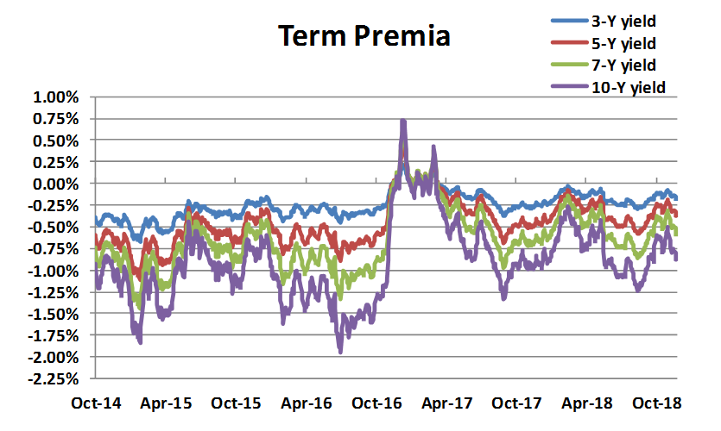

* The compensation for taking yield curve risk has slightly moved down again, and is well in negative territory for all maturities between 3 and 10 years. The reason is simple: the market yields are now below the expected path of the short rate (the “blue dots”), despite the very subdued projections of the Fed, which have never been lower, and which now even seem to imply a rate cut in the medium future.
* Much has investors have been fretting about the possibility of a recession being priced in the shape of the yield curve, the most striking observation is by how much the Fed has lowered its expectations for the long-term target of the Fed fund rate, with the median last blue dot now below 3%. With an inflation target between 2% and 2.5% this implies a long-term projection of virtually zero real growth.
* Why are market yields below the path of the blue dots? There can be two explanations: either the market expectations differ from the projections of the Fed; or there is a negative risk premium (as our model captures). A negative compensation for taking risk is compatible with Treasuries being perceived as a portfolio hedge to equity risk. The recent equity market turbulence makes the desire for equity protection topical.
* In sum: Very low real long-term growth implied by the yield curve. Perhaps a recession in the medium term priced in the path of the blue dots and the shape of the yield curve. Risk premia small and negative, consistent with Treasuries being perceived as “equity insurance”. What rests to be seen is whether, when push comes to shove, after the Greenspan/Bernanke/Yellen put” we will see the Powell put. Politics says that we will; monetary considerations make us more cautious.

**Highlights June-September 2018**

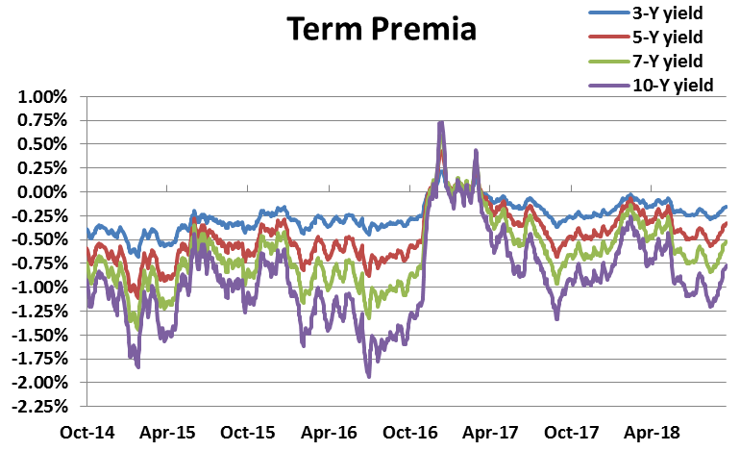

* All of our indicators signal an up-tick for risk premia of all maturities. In a nutshell this is due to fact that since the last quarters yields have risen, but the projections embedded in the Fed “blue dots” have not (if anything, for some maturities the median has marginally decreased).
* The equity sell-off experienced in mid-October poses the first taste of an awkward monetary policy test: after the Greenspan/Bernanke/Yellen put, are we going to experience the Powell put?
* This is crucial for risk premia: if the Fed intentions remain undeterred in the tightening path, but long-term yields decline, this will shrink again the risk premia, and vice versa.
* As a result, if stock market volatility persists and becomes more serious, risk premia in the short-to-medium term will reflect a tug-of-war between the Fed intentions (the “blue dots”), the Fed believability, and what the market thinks the actual Fed response will be. Despite the fact that this will result in a choppy risk premium, what is actually at play is really a complex interaction between different expectations.
* Across the curve, short maturities still offer the most ‘attractive’ risk premia, but it is still truly a best-looking-horse-in-the-soap-factory competition.

**Highlights April-June 2018**

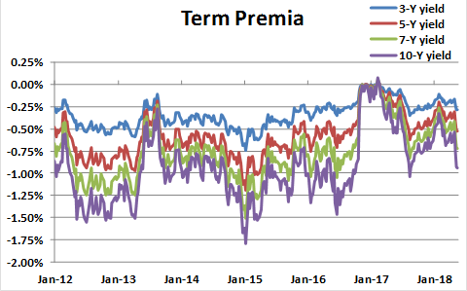

* As the Fed continues its programme of normalization of monetary policy, yields are inching their way towards more positive territory, with the 10-day Treasury yield now firmly in the 3.00% area.
* Does this mean that it is now a good time for fixed-income investors to ‘push out the boat’ and lengthen the duration of their portfolios?
* Not necessarily: as the **EDHEC Risk Premium Monitor** shows, expectations of future yields have risen sharply in the last 12 months, but the compensation for taking duration risk has not increased – if anything, it is back to (negative!) levels seen in 2012-2013.
* From the perspective of a fixed-income investor, the **EDHEC Risk Premium Monitor** predicts that it is still more advantageous to roll short-term-maturity investments, than to invest in long-maturity bonds.
* The effectiveness of Treasuries as hedges against equity risk is to be tested under the new Chairman (after the Greenspan, Bernanke and Yell ‘put’, are we going to see a ‘Powell put’?) Given this fundamental policy uncertainty, the (negative) compensation for taking duration risks appears very unappealing.

**Highlights Dec 2017-April 2018**

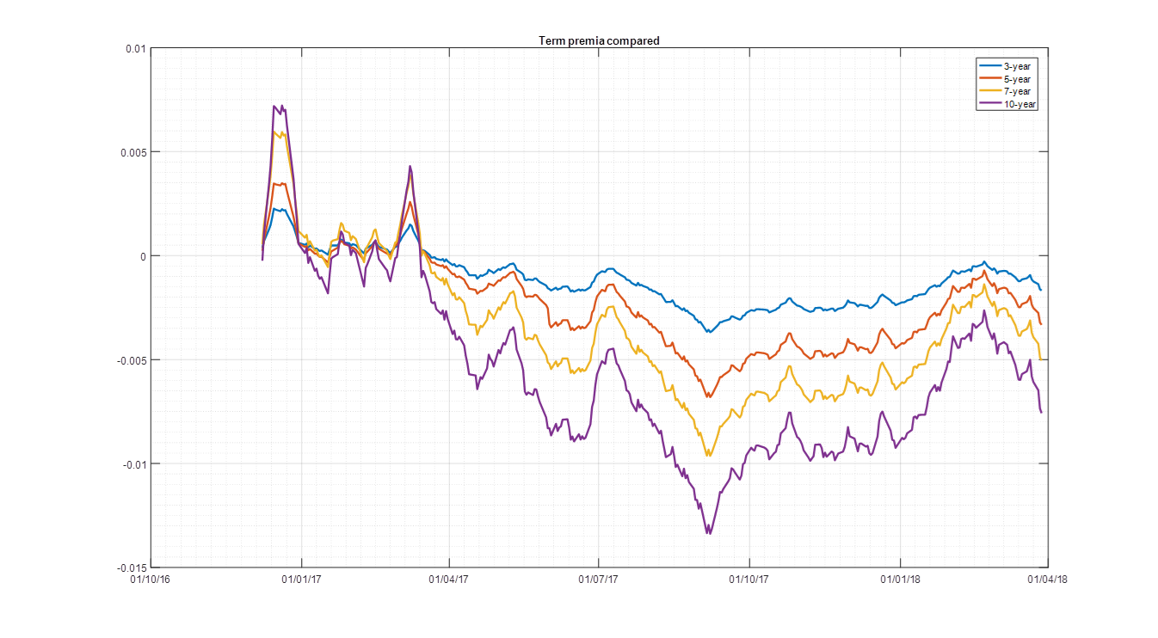

* After the brief increase in Q4 2017, in the first quarter of 2018 term premia have decreased again.
* The main reason is that expectations about the path of the Fed Fund rate (as proxied by the expected path of the Fed “Blue Dots”) have increased significantly – this has been the first quarter on record for which the projections of the Fed members have been revised substantially upwards – but market yields have not increased nearly as much.
* The brief flirtation with the 3.00% level of the 10-year yield has quickly been reversed, and was in any case associated with expectations of a more aggressive hiking path, not with increased risk premia.
* By historical standards, investors remain very poorly compensated for taking duration risk – the more so at the long end of the yield curve.

**Highlights 22-Sep/19-Dec 2017**



* In the last quarter there has been a mild recovery of term premia, which however remain at very low levels. In the short-to-medium end of the curve, market yields have risen, roughly in line with the forward rates projected as of September. As the “expectations” obtainable from the Fed “blue dots” have hardly changed, this has given rise to the modest increase in term premia.
* The big difference with respect to 9 months ago is that now the worst term premia are offered by the 10-year bonds. This is easy to understand, as a continuation of a longer-term bear flattening of the yield curve, with short-dated market yields rising with respect to longer dated ones. Since the blue dots have, if anything, declined across the curve, over the last 9 months *the term premia have deteriorated at the long end*. They have staged a modest recovery in the first part of Q4 2017, but they still remain more depressed than the short-dated term premia.

**Highlights 15-Jun/21-Sept 2017**

**Both the statistical and the model-based estimates of the term premia show a significant decline (especially for long yield) since June. Why is this happening? Should the results be believed?**

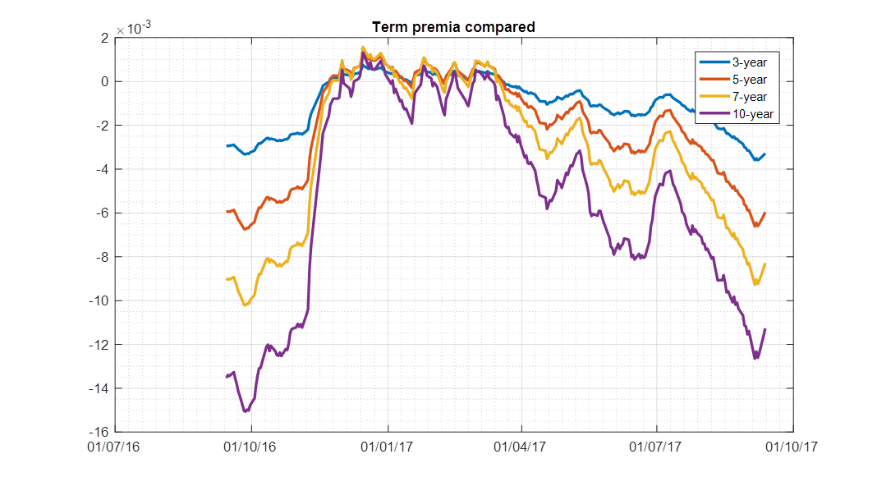

• From June to the beginning of September the long end of the yield curve has experienced a significant flattening, with the 10-year yield declining from its July peak by approximately 40 basis points, and the 3-year yield remaining almost unchanged (if anything, moving slightly up).

• The “blue-dots” rate expectations of the Fed have softened marginally at the very long end, but have remained unchanged at the short end *for the same projection dates, despite the fact that, during the last quarter, forward rates ‘have not come* true’ – ie, despite the fact that the monetary tightening has slightly lagged the path projected in June.

• Unchanged blue dots for a closer horizon plus a lag in June’s expected path of tightening has given rise to a short-term steepening of expectations.

• Higher real-world expectations and lower yields explain the lower risk premia embedded in the yield curve with respect to a quarter ago.

• **Warning**: the blue-dots express a median, not an expectation. Recent geo-political events (such as North Korea) suggest that, for the same median, the distribution of future Fed funds may be more skewed towards low rates. **This would imply lower expectations and, in turn, a smaller fall in risk premia.**